**ASSIGNMENT 2 - Project Title: FoodFort**

# Introduction

The objective of this project is E-commerce solution to the café DrinkLab, Mangalore. The main goal of this system is to enable the customer an easy food ordering experience. The customer will be able to order food at his/her convenience without having to visit the café. The admin will receive the orders placed by the customers. The admin will be able to add items if any new items are available. The admin will be able to modify the available items.

The following are the software requirements:

1. Registering account/Login – It would enable the customer to have an account and view his previous transactions, orders details.
2. Cart – The cart is a functionality is where the users would add the potential food products that they might be planning to buy.
3. Checkout – Checkout is the functionality where the users enter the delivery details such address etc which would be stored in the database and can be viewed by the admin
4. Payment – Functionality to pay online for the user’s orders.

# User Interface Design and Prototype

Homepage Part 1:

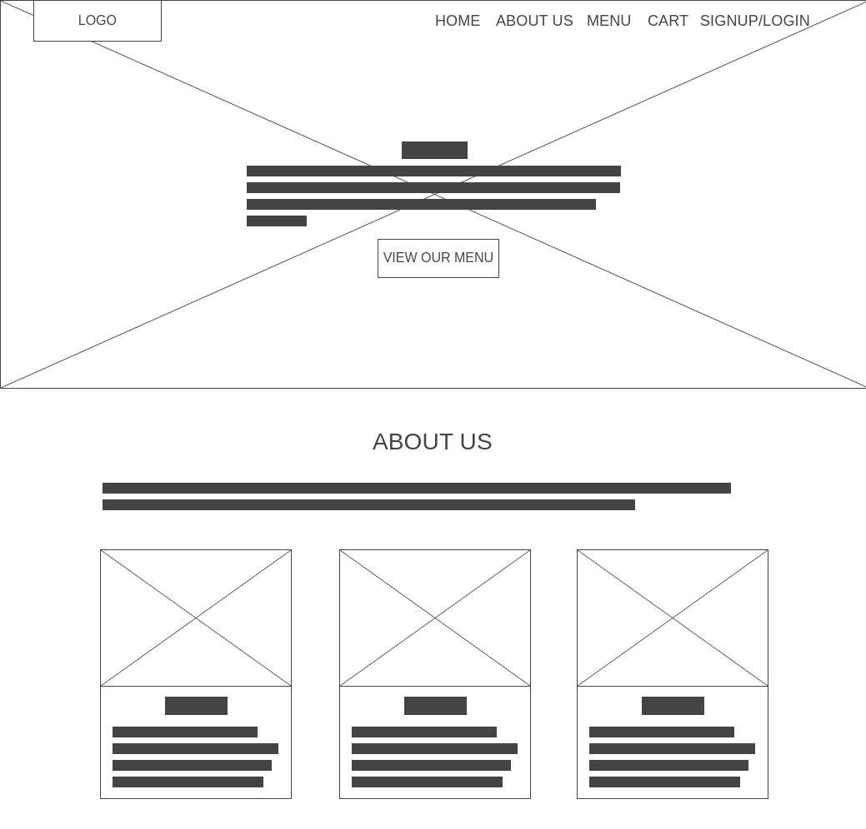

Homepage Part 2:

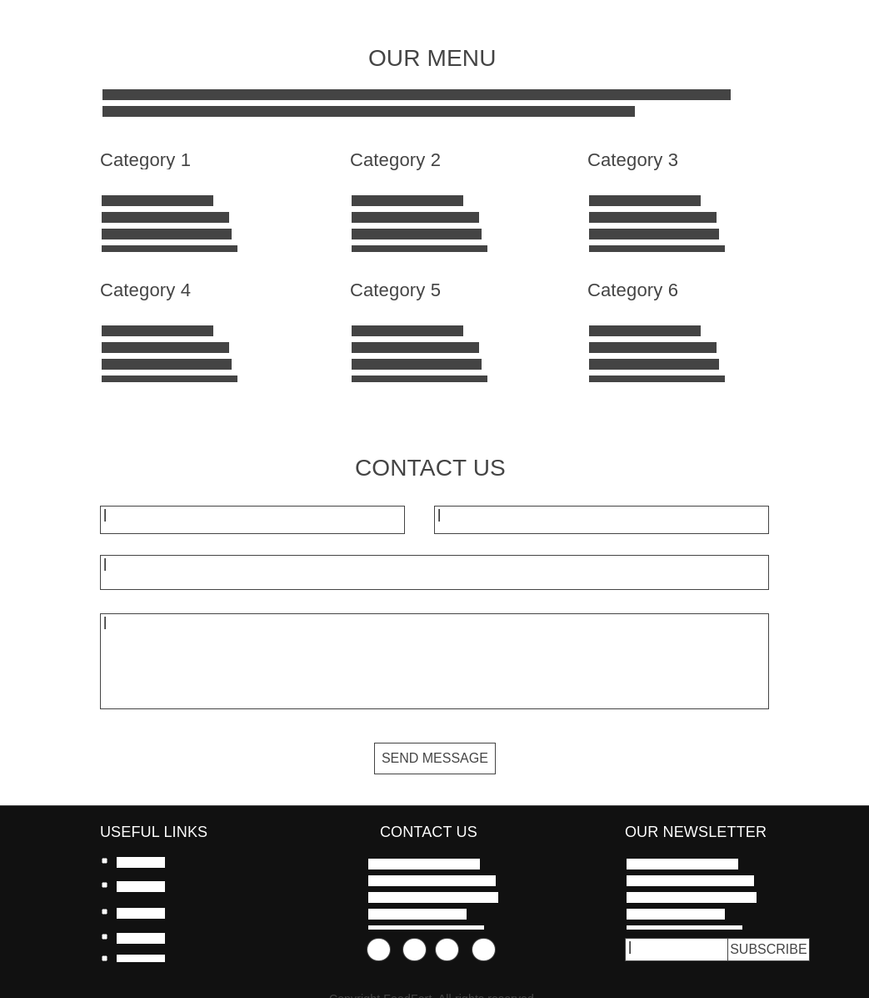

# Navigation Structure

The user enters the website (shown above), clicks on MENU shown on the navbar which will scroll to the OUR MENU section. This section has multiple food categories from which the user can explore any category.

Then the user selects the food item, adds to cart and then proceeds for checkout.

Structure:

HOMEPAGE -> MENU -> EXPLORE FOOD ITEMS -> ADD TO CART -> CHECKOUT

# References

1. [www.wireframe.cc](http://www.wireframe.cc)
2. Building ECommerce Applications, Devzone